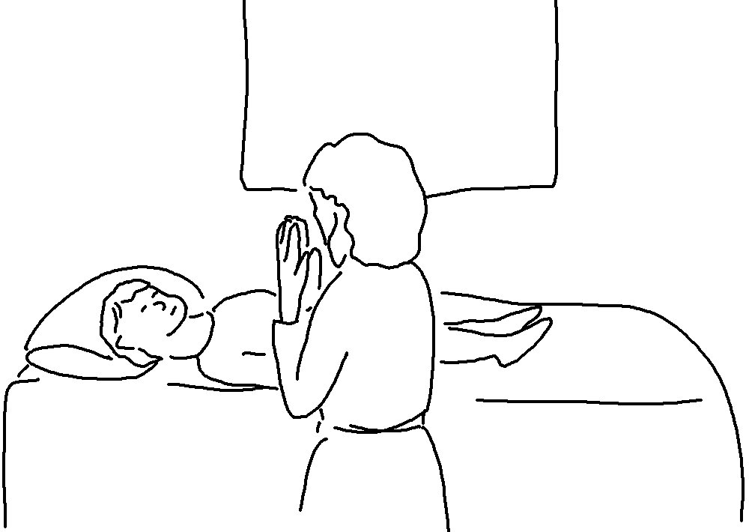
Matthew 6:8_{NLT}
Your Father knows exactly what you need.

